Practical 28
Code
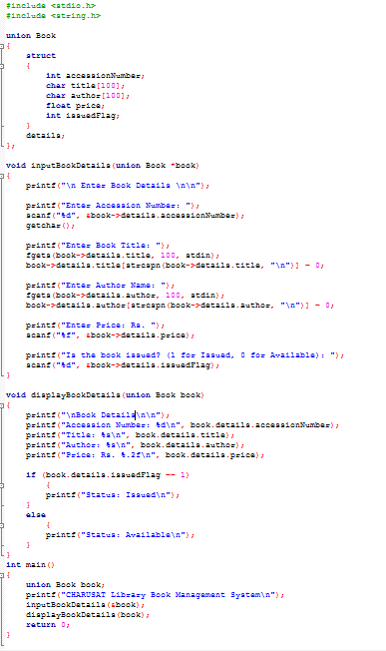

Output
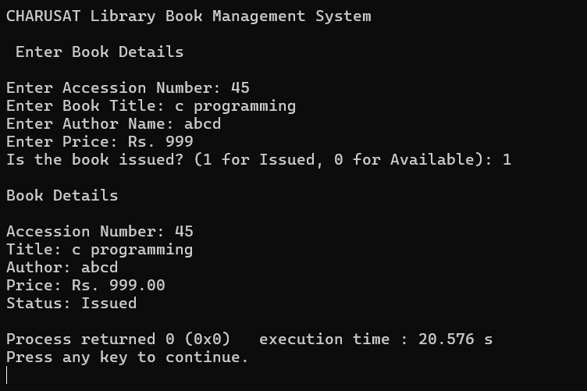
This program is done by YATISOLIYA_25CE118

